Bootstrap / jQuery Navbars

Links for Navbars:

1. https://colorlib.com/wp/bootstrap-navbar/
2. <https://www.mockplus.com/blog/post/bootstrap-navbar-template>
3. <https://colorlib.com/wp/jquery-navigation-menu-bar-plugins/>

Audio/Video Tags

* Audio and video tags are used to place audio files and video files on the websites
* <audio></audio>
* <video></video>

Example on Video Tag

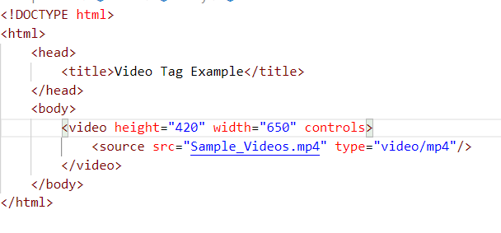

Example to place the Youtube video in Webpage:

Goto the video - Open the video - down the video you will find the option called “share” - select the option as “Embed” and it will produce the Html with iframe tag

Copy that iframe and paste in the website

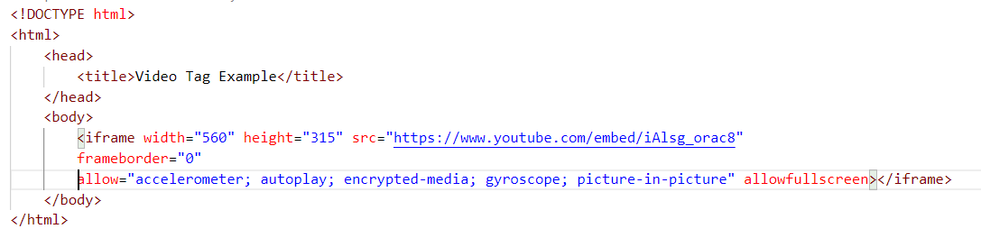

Example on Audio Tag;

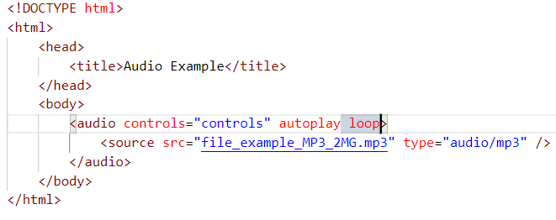

Example of Audio using JS

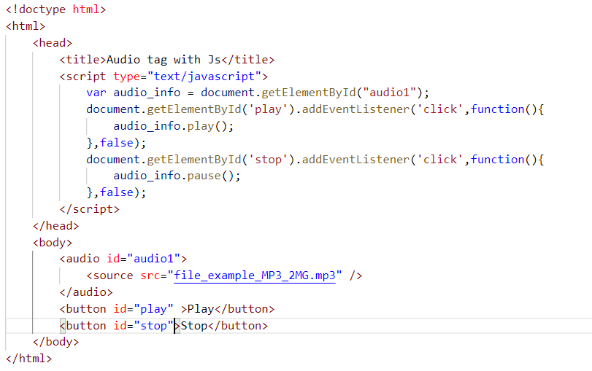

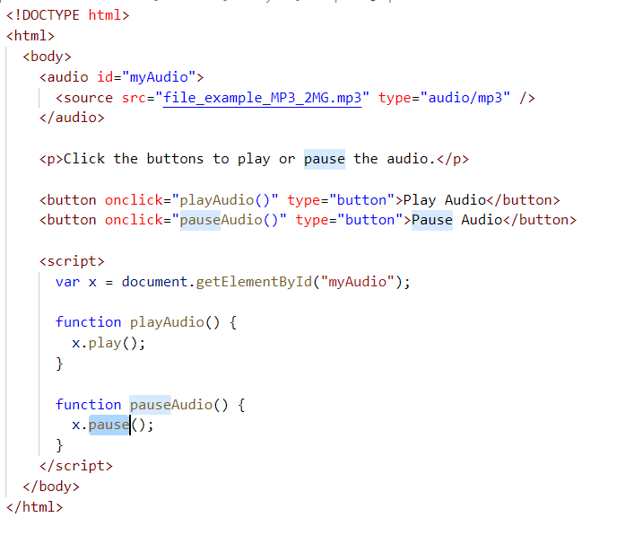

GeoLocation

